**Aim:** Write an algorithm and program to sort n numbers using Bubble sort technique.

**i)** Using iteration

**Source code:**

#include <stdio.h>

#include<conio.h>

#define MAXSIZE 10

void main()

{

int array[MAXSIZE];

int i, j, num, temp;

printf("Enter the value of num \n");

scanf("%d", &num);

printf("Enter the elements \n");

for (i = 0; i <num; i++) {

scanf("%d", &array[i]);

}

for (i = 0; i <num; i++){

for (j = 0; j < (num - i - 1); j++)

{

if (array[j] > array[j + 1])

{

temp = array[j];

array[j] = array[j + 1];

array[j + 1] = temp;

}

}

}

printf("Sorted array is:\n");

for (i = 0; i <num; i++)

{

printf("%d\t", array[i]);

}

getch();

}

**OUTPUT:**

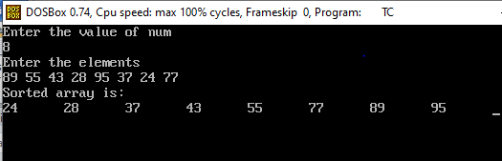

**ii)** using recursion

**Source code:**

#include<stdio.h>

#include<conio.h>

void Recursion(int a[],intnum);

void main()

{

inti,j,num,temp,a[10];

clrscr();

printf("Enter number of elements\n");

scanf("%d",&num);

printf("Enter numbers\n");

for(i=0;i<num;i++)

{

scanf("%d",&a[i]);

}

Recursion(a,num);

printf("Ascending oreder of given numbers is\n");

for(i=0;i<num;i++)

{

printf("%d\t",a[i]);

}

getch();

}

void Recursion(int a[],intnum)

{

inti,j,temp;

i=num;

if(i>0)

{

for(j=0;j<num-1;j++)

{

if(a[j]>a[j+1])

{

temp=a[j];

a[j]=a[j+1];

a[j+1]=temp;

}

}

Recursion(a,num-1);

}

else

{

return;

}

}

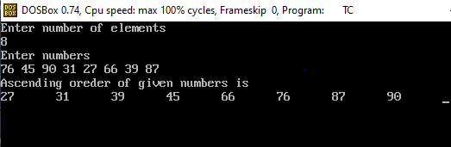

**Complexity:**

Best case: O(n)

Worst case: O(nˆ2)

Average case: O(nˆ2)